ASTO Web Portal Read-Only Access Guide

This guide will assist Read-Only access users to:
- Retrieve e-Statements
- Retrieve transactions
- Reset password
The user will need to have access to the ASTO Web Portal website:
https://www.your-fundaccount.com/ASTO/Login.aspx

How to Retrieve e-Statements?
- Login in to the ASTO Web Portal using your username and password.
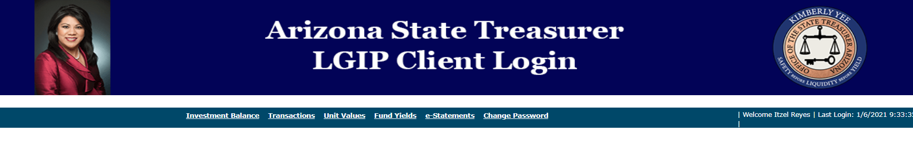
- Select e-Statements

- Look for the account number or group number associated with your agency on Select Account.

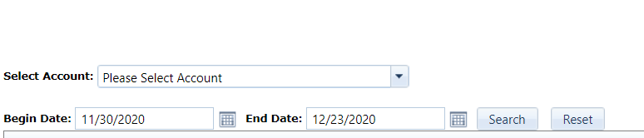

- Enter a Begin Date and an End Date to retrieve statements for any date range. Select Search once the information is entered or select Reset to start a new search.
- Click on View Statement once an account number or group number has been entered.

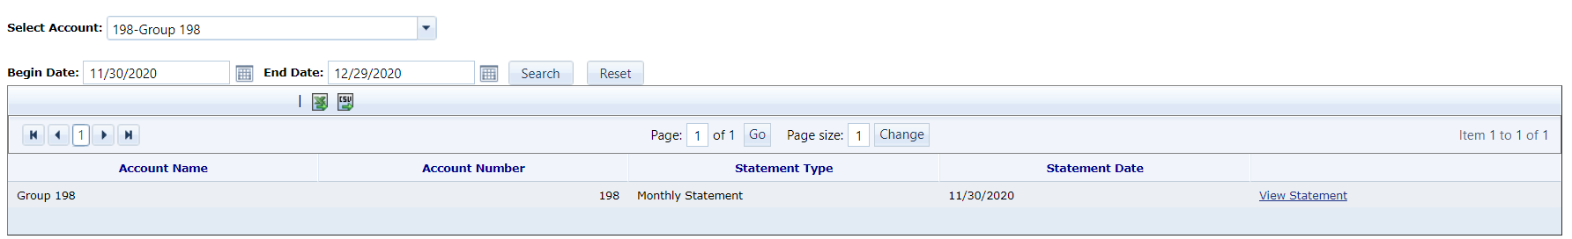

- Send emails to LGIP@aztreasury.gov if you have difficulty retrieving statement(s).

How to Retrieve Transactions?
- Login in to the ASTO Web Portal using your username and password.
- Select Transactions
- On Begin Date and End Date, choose the dates that are close to the transaction and select Search. If needed, you can look for a transaction by entering information in the given sections below.
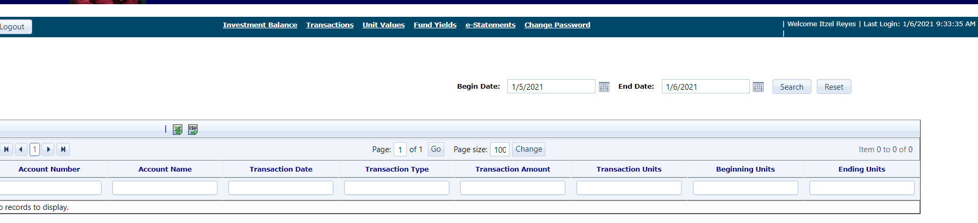
- Send emails to LGIP@aztreasury.gov if you have difficulty retrieving transaction(s).

How to Reset Your Password?
- Go to the ASTO Web Portal: https://www.your-fundaccount.com/ASTO/Login.aspx
- Select the Forgot Your Password link.

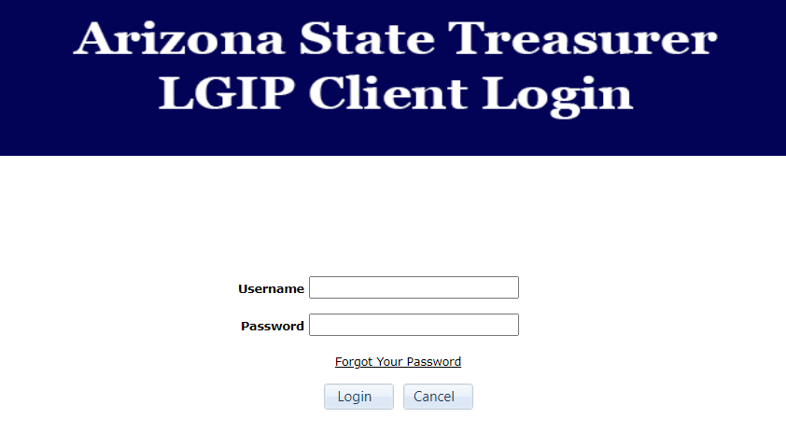

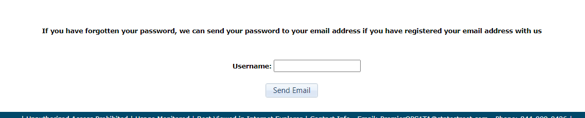
- Enter your ASTO username and select Send Email. Send emails to LGIP@aztreasury.gov if you need further assistance with your username.

- State Street Administration will send you an email with a temporary password and link to change your password. If you have not received an email from State Street Administration through your inbox, please check your junk mail.

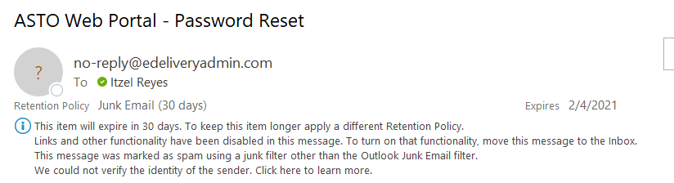
- Select the link on the email. It will send you to the ASTO Web Portal login. Enter your username and temporary password.
- It will direct you to a web page allowing you to reset your password. Enter the temporary password on the Enter Current Password box. The new password needs to contain at least 1 Uppercase, 1 Digit and 1 Symbol; less than 15 characters.

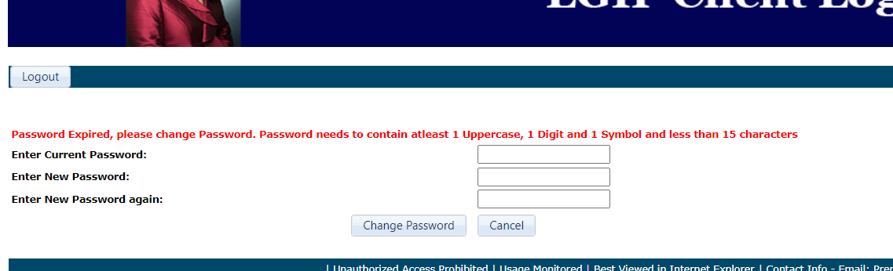

- You will need to re-login with your username and new password once you select Change Password.

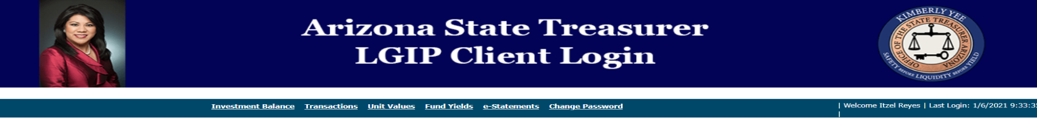
Also, user can change their current password by selecting Change Password on the web portal.

